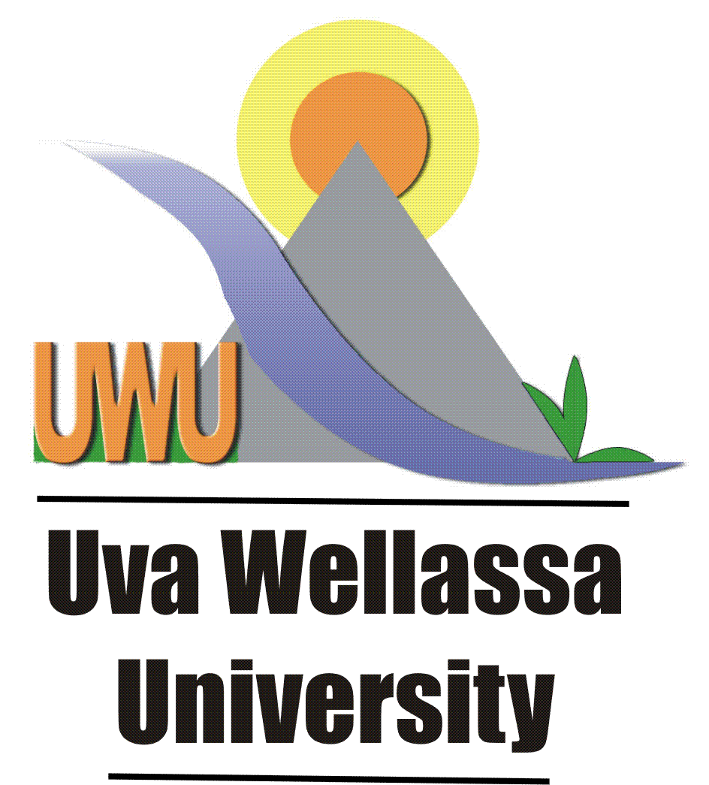

Take pride in contributing to the National Development

Vacancies – Uva Wellassa University

01) Nursing Officer (Grade II)

Qualifications:

G.C.E. (Ordinary Level) Examination in six subjects at not more than two sittings with credit passes in 03 subjects.

AND
Certificate of competence as a Nurse recognized by the Sri Lanka Medical Council

Selection by : By Test & Interview
Salary Scale : U-MT I (III) Rs. 51,095-7X540-10X640-60,575 p.m.
Age : Not more than 45 years

02) Farm Supervisor (Grade III)

Qualifications:

G.C.E. (Ordinary Level) Examination in six (6) subjects at not more than two (2) Sitting with Credit passes in Sinhala / Tamil / English Language or Literature and Arithmetic / Commercial Arithmetic / Mathematics.

AND
Practical Farm School Certificate or equivalent with ten years’ experience in a State Organization after obtaining such certificate

OR
School of Agriculture Diploma (Peradeniya or Kundasale) or equivalent with five years’ experience after such Diploma.

Selection : By Interview
Salary Scale : UMT 1 (III) Rs.51,095– 7x540 ; 10x640 – 60,575 p.m.
Age : Not more than 45 years

03) Management Assistant Grade III (Shroff)

Qualifications:

Should have passed the G.C.E. (O/L) Examination in six (6) subjects at one sitting with credit passes in:-

- Sinhala Language /Tamil Language
- English Language/ English Literature
- Mathematics

Should have passed in all subjects at subjects at G.C.E. (A/L) Examination (except the Common General Papers) at one sitting and one shall be for Accountancy.

Preference will be given to those who possess the following:

An acceptable qualification in computer qualifications of not less than six (06) months duration obtained from a recognized institute.
AND

Two years of experience in the use of computer application packages.

Note: A security deposit to be furnished as determined by the UGC/ Higher Educational Institution.

Selection : By Written Examination and Interview
Salary Scale : U-MN1 (III) Rs. 49,475 – 17x540– 58,655 p.m
Age : Should be not less than 18 yeas and not more than 30 years

Other Conditions

- All Applicants should be a Sri Lankan Citizen.

- The duly completed application on prescribed forms together with the copies of relevant certificates and complete curriculum vitae should be sent under Registered cover to reach the Senior Assistant Registrar, Human Resources Division (Non Academic), Uva Wellassa University, Passara Road, Badulla on or before 19th October 2026 The application forms and relevant information could be downloaded from the University website http://www.uwu.ac.lk/vacancies/.

- The candidates who apply for more than one post should submit separate applications in separate covers for each post. Please mark relevant post on the top of the left-hand corner of the envelop.

- Candidates in the service of the University Grants Commission and Higher Educational Institutes, Government Departments, State Corporations and Statutory Boards should channel their applications through the Heads of their respective Institutions. Advance copies of applications may be sent in the first instance. Applications which are not forwarded through the respective Heads of Departments will be rejected.

- Age limit is not applicable for applicants in the service of the Government Departments, State Corporation and Statuary Boards.

- Incomplete applications, applications without supporting documents and applications received after the closing date will not be considered. University reserves the right to shortlist the candidates and call only such candidates for interview.

Acting Registrar
Uva Wellassa University

055 - 2226441
2026.09.20

