GUIDELINES FOR AUTHORS

General Information
Journal of Technology and Value Addition (JTVA) features Original Research Articles, Review Articles, Short Communications and Case Studies in Social Sciences and Humanities, Natural and Applied Sciences, Engineering and Technology and other fields acceptable to the Editorial Board.

Types of Research Papers
Research article: A regular full-length article (less than 5000 words text), reporting of original research with an abstract of 300 words.
Review articles: An article covering subjects falling within the scope of the journal which are of active current interest. The word limit is 6000.
Case study: A research paper involving an up-close, in-depth, and detailed examination of a subject of study (the case), as well as its related contextual conditions. The word limit is 5000.
Short communications: Short research papers which have one or two results of particular interest or importance, but not the body of work expected in a full-length paper. Authors are expected to keep Short Communications very concise. The word limit is 3000.

Guidelines for Authors
We strongly recommend authors to read Author Guidelines carefully before submission of manuscripts. Submission of a manuscript, according to the Guidelines for Authors, will ensure that your submission will receive the attention it deserves, and also reduce the chances of delays due to improper submission.

Cover Letter
A letter addressed to the Editor-in-Chief must accompany the manuscript, and it must contain the following elements. Please provide these elements in the order listed below:

- Your manuscript’s title.
- Type of manuscript (Original Research Article/Review Article/Case Study/Short Communication).
- Statement that your paper has not been previously published and is not currently under consideration by another journal.
- Brief description of the research you are reporting in your paper, why it is important, and why you think the readers of the journal would be interested in it.
- Contact information for you and any co-authors.
- Confirmation that you have no competing interests to disclose.

Submission of Manuscript
Manuscripts must be written in English. Manuscripts should be submitted electronically to JTVA to facilitate rapid publication and minimize administrative costs. All manuscripts should be submitted to Editor-in-Chief by the Corresponding Author using the e-mail provided (jtva@uwu,ac.lk). The Corresponding Author takes responsibility for the paper during submission and peer review.

Manuscript Structure
Manuscripts must be arranged in the following order: Title page with Authors and their affiliations, Abstract, Keywords (4-6), Introduction, Materials and Methods, Results, Discussion/or Results and Discussion, Conclusion, Author Contribution, Funding (if any), Acknowledgements, Conflict of Interest, References.
Please prepare the manuscript using the template given by JTVA to facilitate easier evaluation and faster processing.

Format for Type Setting
The manuscript must be typewritten using MS Word® 2007 or a later version. All pages must be numbered starting with the title page and lines must be consecutively numbered from the start to the end of the manuscript excluding the abstract. Use Cambria 12-point size only, and Symbol font for mathematical symbols (in the text and in the Figure). The text should be justified.

Please follow the guidelines given below strictly:
• Paper size: A4 (210 × 297 mm)
• Margins: Top, bottom, left and right margins of 2.54 cm (1”)
• Line spacing: 1.15
• Column – Single column
Author names and affiliations: Clearly indicate the name(s) of each author and check that all names are accurately spelled. Present the authors' affiliation addresses below the names indicated with a lower-case superscript numeral immediately after the author’s name. Provide the full postal address of each affiliation and the e-mail address of the corresponding author. Clearly indicate the corresponding author by asterisk (*) his/her name.

Abstracts and Keywords
An abstract is required only for some categories of the manuscript. The abstract should not exceed 300 words and convey the essence of the contribution even to a non-specialist reader. For a research article, the abstract should include a few sentences of background to the work, the rationale, and the main results and conclusions. Abbreviations are discouraged.
Immediately after the abstract, provide a maximum of 4-6 keywords separated by commas, that indicate the most important topics used in the article.

Introduction
The introduction should give the pertinent background to the study and should explain why the work was done showing the existing research gap. Finally, briefly mention the main aim of the work. References should be cited intext in the Introduction and under other titles where relevant. See the end of the document for further details on references.

Materials and Methods
The materials and methods (or methodology) should give essential details, including experimental design and statistical analysis.

Results
The results should present the findings of the research. They should be free from discussion. Results should be written in the past tense.

Discussion
The discussion should cover, but not simply repeat the new findings and should present the author's results in a broader context of other work on the subject interpreting them with a minimum of speculation and ending with a conclusion.
Note: When ‘Results and Discussion’ are presented together the manuscript should be arranged in a way that both the ‘Results’ and ‘Discussion’ are presented and described sufficiently giving a justifiable space to each component harmonizing them carefully.

Conclusions
This section should explain the brief summary and conclusions that we can draw from the present study.

Author Contributions

For research articles with several authors, a short paragraph specifying their individual contributions must be provided.

Funding

Mention the source of funding if any.

Acknowledgements
Acknowledgments should recognize contributions from non-authors, institutes and funding organizations contributed to the success of the research. The acknowledgements should be as brief as possible.

References
Please ensure that every reference cited in the text is also present in the reference list (and vice versa). When two or more references are to be cited together, they should be given in the text chronologically from the earliest to the most recent. Unpublished results and personal communications are not recommended as references. We recommend preparing the references with a bibliography software package, such as EndNote, Mendeley Reference Manager and etc to avoid typing mistakes and duplicated references. Include the digital object identifier (DOI) for all references where available.
Citing References in the Text: All citations in the text should refer to:
- Single author: the author's surname/family name (without initials) and the year of publication (e.g., Sepaskhah, 2010)
- Two authors: both authors' names and the year of publication (e.g., McVeigh and Morgue, 2014)
- Three or more authors: first author's name followed by 'et al.' and the year of publication (e.g., Mason et al., 2015)
Reference List: References should be arranged alphabetically. More than one reference from the same author(s) in the same year must be identified by the letters 'a', 'b', 'c', etc., placed after the year of publication. The year of the reference should not be too old. References and citations of references should be according to the Harvard system.

Full detailed referencing guide available at - https://www.dkit.ie/assets/uploads/documents/Library/Documents/DkIT%20Guid e%20to%20Harvard%20Referencing.pdf

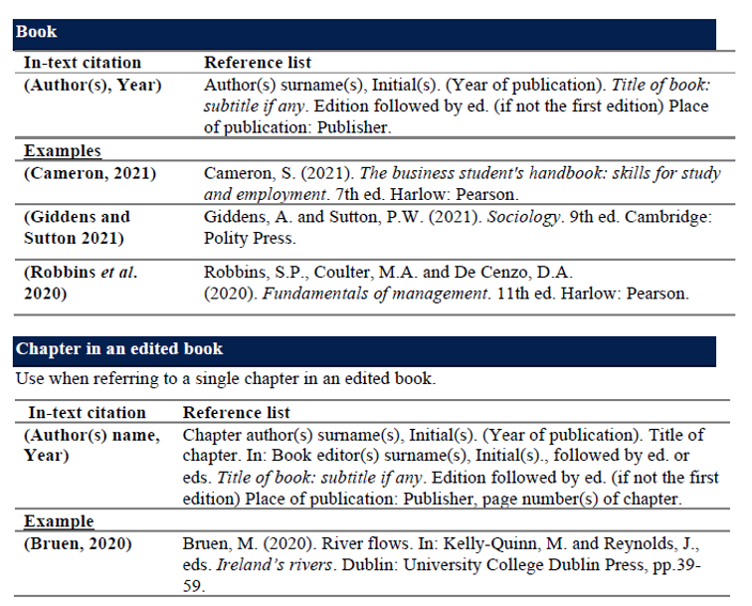

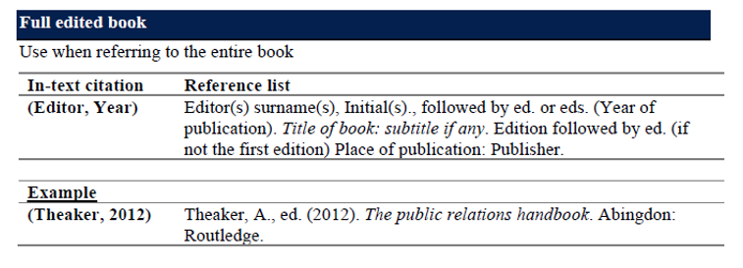

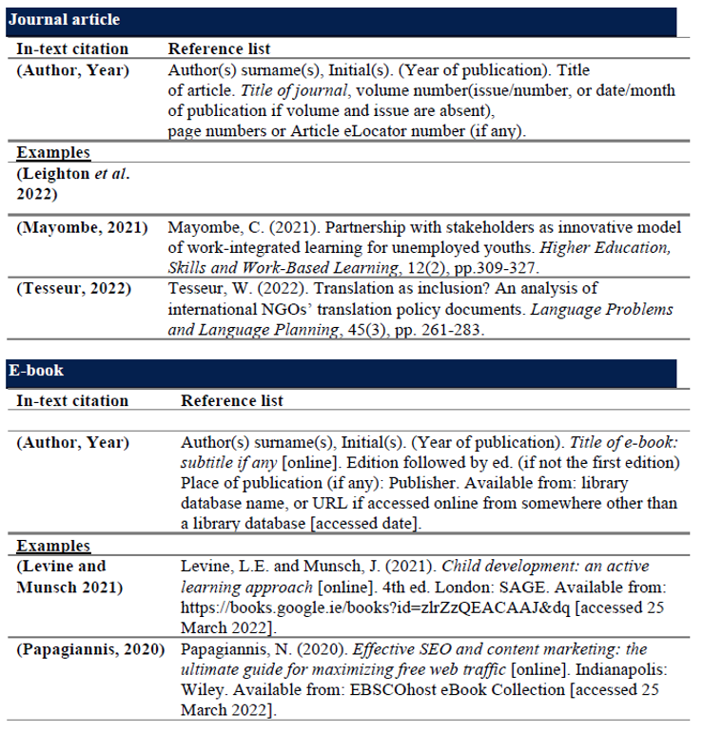

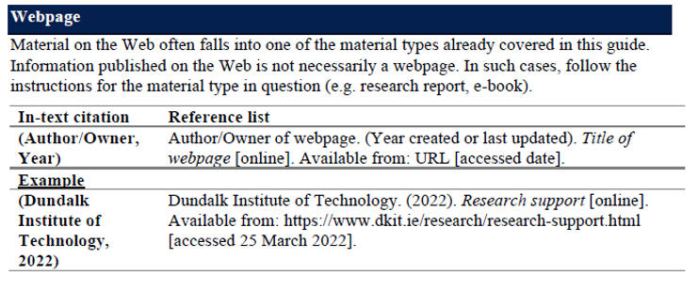

Abbreviations
Define abbreviations that are not standard in this field in the text where they are first presented. Such abbreviations that are unavoidable in the abstract must be defined at their first mention. Ensure consistency of abbreviations throughout the article limiting to a minimum number of abbreviations is encouraged.

Nomenclature and Units
All crops, plants, insects, birds, mammals, microorganisms, etc. should be identified by their scientific names.
For chemical nomenclature, the conventions of the International Union of Pure and Applied Chemistry and the official recommendations of the IUPAC-IUB Combined Commission on Biochemical Nomenclature should be followed.

The SI system should be used for all scientific and laboratory data. A single space should be allowed between the numerical value and the unit (e.g., 10 kg). In certain instances, it may be necessary to quote other units. These should be added in parentheses. Temperatures should be given in degrees Celsius (e.g., 37°C, 50%). Use SI symbols in format of km h-1/ g mol-1, instead of using km/h or g/mol.

Tables, Figures & Illustrations
Figures should be saved in a neutral data format such as JPEG or TIFF and should have a resolution of 300 dpi. Any tables and Figures that are included in the main text of the paper should be numbered separately, in the sequence that they are mentioned in the text (e.g., Table 1). Each table and Figure should be presented on relevant place of the manuscript, with a brief and self-explanatory title. The title of tables should be placed above the tables and the title of Figures placed below it. Tables should use horizontal lines only, with only blank spaces to separate columns.

Additionally, they should be submitted on a separate sheet of paper, numbered in order. To facilitate layout and typesetting, the editable files of the tables and figures will be required when a paper is accepted for publication.
Text for tables and figures should not be smaller than 10 points and should be in same font as in the text (Cambria). Scanned or digital photos should be of high resolution (minimum of 300 dpi). Table and Figure legends should be in 10 points.
Journal of
Technology and
Value Addition
JTVA

Figure 1. This is a figure.

Title 1 | Title 2 | Title 3
entry 1 | data | data
entry 2 | data | data
Table 1. This is a table. Tables should be placed in the main text near to the first time they are cited.

¹ Tables may have a footer.

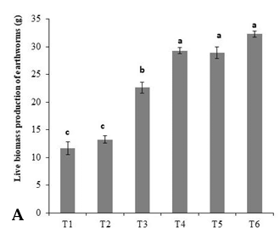 | 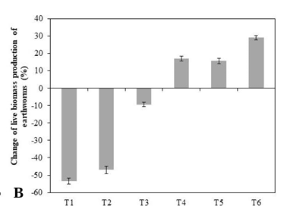
(a) | (b)
Figure 2. This is a figure. If there are multiple panels, they should be listed as: (a) Description of what is contained in the first panel; (b) Description of what is contained in the second panel. Figures should be placed in the main text near to the first time they are cited.

Formatting of Mathematical Components

Equations should be inserted in editable format from the equation editor in word.
This is example 1 of an equation:
$A=πr^{2}$, | (1)
the text following an equation need not be a new paragraph. Please punctuate equations as regular text.
This is example 2 of an equation:
$${\left(1+x\right)}^{n}=1+\frac{nx}{1!}+\frac{n\left(n-1\right)x^{2}}{2!}+…$$ | (2)
the text following an equation need not be a new paragraph. Please punctuate equations as regular text.

Submission of the Manuscript
Submitted manuscripts must not have been published previously nor be under consideration for publication elsewhere. Moreover, submission to the Journal of Technology and Value Addition will be deemed to imply that the manuscript will not be submitted elsewhere if accepted.
Mode of submission - Email – jtva@uwu.ac.lk

Manuscript Acceptance Policy
Manuscripts are accepted for publication subject to copyediting. Manuscript submission indicates the author's commitment to publish in JTVA and to give JTVA first publication rights. No paper known to be under consideration by another journal will be reviewed.

Initial Assessment of Manuscripts
JTVA is committed to publishing high-quality new work that makes a significant contribution within the scope of the journal. In order to meet this aim, submitted manuscripts undergo initial evaluation by an editor to ensure that they meet essential criteria for publication in the journal. Only those manuscripts that pass this initial review process will be forwarded to reviewers for further consideration.

Peer Review of Manuscripts
JTVA adopts a double-blind peer review process. The Editors select reviewers and make the final decision on the manuscript. Reviewers remain unknown to the authors.

Revised and Final Versions of Manuscripts
Authors of accepted manuscripts should submit their final revision in Microsoft Word (doc.) format as an e-mail attachment with evidence to prove that they have worked for the given comments. When submitting a revised manuscript, please include your responses to the reviewers' comments as part of the cover letter file. Include all Figures with the revised submission, even if they have not changed during the review process. For both revised and final versions of manuscripts, please observe the same formatting instructions outlined above.

