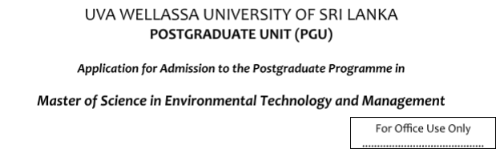
FULL NAME: (Mr. /Miss/Mrs.) ......................................................................................................................................……………
(Please write in capitals)
MAILING ADDRESS: ..................................................……………………  ................................................…………………………………………………… ................................................…………………………………………………… ................................................…………………………………………………… | Phone: ..........................……… Fax: .......................................... E-mail: ...............................……
HOME ADDRESS: ................................................………………………… ................................................…………………………………………………… ................................................…………………………………………………… ................................................…………………………………………………… | Phone: ..........................………
DATE AND PLACE OF BIRTH: ..............................…………….. ………………..  CIVIL STATUS: ...........................………………… SEX (M/F): ...................... | CITIZENSHIP: ............................ NATIONAL ID NO.: .................…
CURRENT EMPLOYMENT (If applicable): (Please attch certified copies of service certificates)
DESIGNATION & ADDRESS: .......................................................................................…………………………………
NATURE OF DUTIES PERFORMED: ..................................................................................…………………………….
YEARS OF SERVICE: ..................................................................................................................………………………..
NAME & DESIGNATION OF EMPLOYER: ………………………………………………………………………………
1
EDUCATIONAL QUALIFICATIONS (including postgraduate qualiﬁcation): Please attach certiﬁed copies of certiﬁcate/s.
University/Institute | Degree/Diploma etc. |  | Year |  | Class/grade
RESEARCH PUBLICATIONS (If ny): (If necessary attach a separate sheet)
REASONS FOR SELECTING THE ABOVE M.Sc. PROGRAMME |  |  |  | Yes |  | No
I am directly involved in this ﬁeld
I am generally interested in the subject
The course might be helpful for my present employment
The degree obtained could be used to further my higher education
The programme might help me to obtain an employment in the Field
Other (specify)
MODE OF PAYMENT OF PROGRAMME FEE:
From personal funds / By employer / Other (Specify)
NAMES AND ADDRESSES OF TWO REFEREES:
1. |  | 2.
I declare that the particulars given above are correct to the best of my knowledge.
Date: ………………….. Signature of Applicant: …………………………………
2
AVAILABILITY OF STUDY LEAVE (applicable to those who are employed):
State whether you are entitled to study leave for the period speciﬁed.
RECOMMENDATION OF THE HEAD OF THE INSTITUTION:
............................................................................... Signature of Head of the Institution
Designation.........................................................
Oﬃcial Stamp:
If Mr./Miss/Mrs. ..................................................................................................................... is selected for the above
programme he/she would be/ not be released on a full/part-time basis.
Name: ...................................................................
Date: .........................................................
3

