Financial Modeling and Analysis Competition 2022
FiMA 2022

Department of Management Sciences
Faculty of Management
Uva Wellassa University of Sri Lanka

Scope of the competition
FiMA 2022 Financial Modeling and Analysis Competition is organized parallel to the UWU Entrepreneur’s Day 2022. The competition is designed under the AHEAD project of the Department of Management Sciences, Uva Wellassa University Sri Lanka. The competition is open for the second year undergraduates of Uva Wellassa University.
The consecutive adverse events that took place in Sri Lanka recently have caused crucial adverse ramifications that resulted in substantial destruction in the business sector (PricewaterhouseCoopers (Private) Limited, 2020). It highlights the necessity to study the financial healthiness of the CSE enlisted companies. As pinpointed by many scholar’s companies have emphasized more on short-run survival than long-run growth (KPMG International Limited, 2020). Thus, the purpose of this competition is twofold; Firstly, it will focus on building a rational model to understand, evaluate, and analyze the prevailing contextual implications on financial performance, position and stability of company over five years’ period, and secondly based on such analysis competition would suggest solid accounting and financial strategies to be executed to minimize the adverse consequences.
Competition Task???
You will be assigned a company enlisted in the Colombo Stock Exchange (CSE) by the Competition organizing committee after team registration. Assuming your team as the finance management team of the assigned entity, develop an excel model to evaluate the financial performance, position and stability of the company over a five (5) years period using financial ratios namely, profitability ratios, liquidity ratios, gearing ratios, efficiency ratios and market ratios. Then compile a report that includes the financial suggestion to overcome these adverse ramifications. Your suggestions require to follow SAF (Suitability, Acceptability and Feasibility) model. Herein, you can consider the financial, accounting and taxation regulatory framework and any other relevant information. Profoundly your suggestions should be practical and general or theoretical solutions will not be added to the marks for evaluations. Eventually, after the submission, you have to present your findings physically at Uva Wellassa University of Sri Lanka but those who can’t participate physically can join via zoom and suggestion in front of a panel.
Steps |  | What's our scope
Step 01 Team Registration |  | A group of five third year Sri Lankan management undergraduates (From one Faculty one group with academic supervisor) have to register for the competition on or before 13th June 2022 using the below specified link;  https://docs.google.com/forms/d/e/1FAIpQLSe4D2lQVwGCU8huG4iiY85XKSPPFGDRcBZ3mtoPsblBmw7PHw/viewform?usp=pp_url
Task 02 Assigning the company |  | You will be assigned a company enlisted in Colombo Stock Exchange (CSE) by the organizing committee. You have to download the annual report of the given company for five years’ period from the Colombo Stock Exchange (CSE) and develop an excel model to evaluate the financial performance, position and stability over a five (5) years period starting from (2022- 2017 or 2021-2016) using financial ratios.  Assigned Company: AIA Group Limited
Task 03 Design the excel model using given template (You can revise it appropriately) | 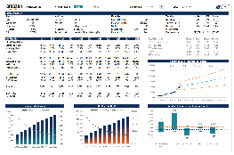 | Excel model should consist of:  - Brief introduction to the Company  - Excel analysis of five types of ratios over five years  - Graphical presentation of periodic change  - All the assumptions made and workings performed should be attached in annexures
Task 04 Writing the Report | 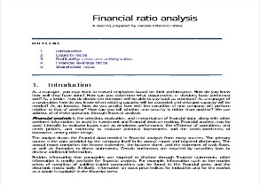 | The report should consist of:  - Executive Summary  - Brief introduction to the Company  - Descriptive analysis of the ratios calculated  - Describe the challenges encountered by the given company due to economic crises and COVID 19.  - Constructively comment on ratios reference to the specified challenges  - Provide robust and comprehensive financial recommendation to cope with these challenges and how they can recover in economic crises.  - Reference list and Appendix (All the workings should be attached in Appendix)  - Students Declaration Page  Report Formatting Guidelines  - Font - Times New Roman (Headings- Size 14, Sub topics -Size 12 (Bold), Body - Size 12)  - Spacing and Alignment - 1.5 Justified  - Maximum word limit - 5000 words (+/- 10% is allowable)  - Maximum No of Pages – (20 – 30 Pages)  - Page Numbering: - Bottom - Centre (Arabic numerals)  - Labeled all tour tables and figures  - Referencing style should be APA
Task 05 Submission of written report |  | Submission of written report and model to the portal on or before 24th June 2022 to bizdms@uwu.ac.lk
Task 06 Presentation / VIVA |  | Eventually after the submission of excel model and report you have to present your findings and suggestion in front of a panel.  Guidelines  - The presentation should highlight the key elements you discussed in the report.  - The presentations should be no more than 10 minutes long.  - The presentations will be conducted physically at Uva Wellassa University of Sri Lanka but those who can’t participate physically can join via zoom.  - After the 10 minutes of presentation; it will be open for 10 minutes’ panel discussion.
Task 07 Evaluations |  | Based on following criteria given in the table, the wining team will be selected.

Task 1: Excel Model | Marks
Calculation of Ratios  Calculation of liquidity, gearing, profitability, efficiency and investor ratios over Five years  Application of correct formula | 10%
Graphical Presentation of Ratios.  Use of range of charts and graphs to present the changes take place over five years | 10%
Task 2: Report
Critical analysis of Ratios.  The ratio analysis results should be critically analyzed based on other financial information and considering all the other relevant published information | 15%
Suggestions and Recommendation  Solid financial recommendation considering all the financial components such as working capital management, and investment financing and dividend decision  SAF (Suitability, Acceptability and Feasibility) evaluation of the alternative suggestions to determine the best | 15%
Formatting and presentation of the report  Adhere to referencing, formatting guidelines  Avoid plagiarism  Reduce grammar and spelling errors | 5%
Task 3: Presentations
The presentation of relevant and significant findings and suggestion | 15%
Confidence and accuracy in answering panel questions | 30%
Total | 100%

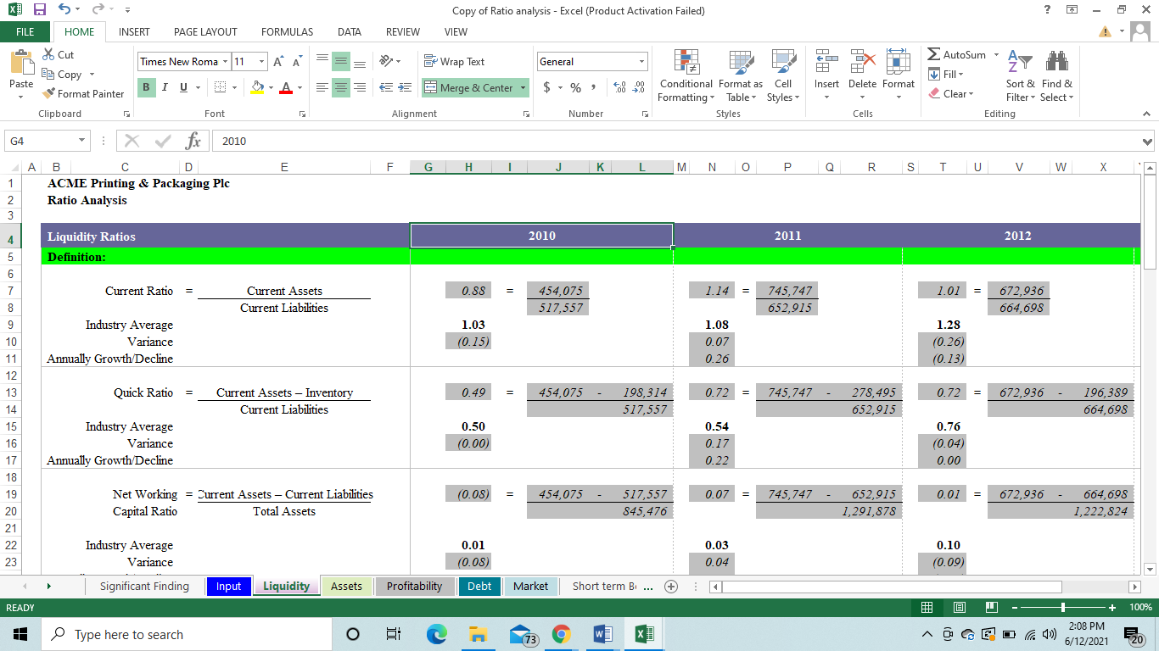
Excel Model

General Guidelines
1. This competition is open for all the Management Faculty 3rd year undergraduates in Sri Lankan Universities.
2. Only one team from one department is allowed to participate in the competition.
3. Only team entries are eligible, and the team shall consist of five members.
4. The unethical behaviors are highly restricted and it can affect eligibility of the team.
5. The competition will be conducted physically at university premises and those who can’t participate physically can join via zoom to the current pandemic situation.
6. Replacement of any participant of a team is not allowed after registration
7. The decision of the judge panel will be final and will not be subjected to any change.

