Application for Reservation of University Guest House |  |  |  |  |  |  |  |  | 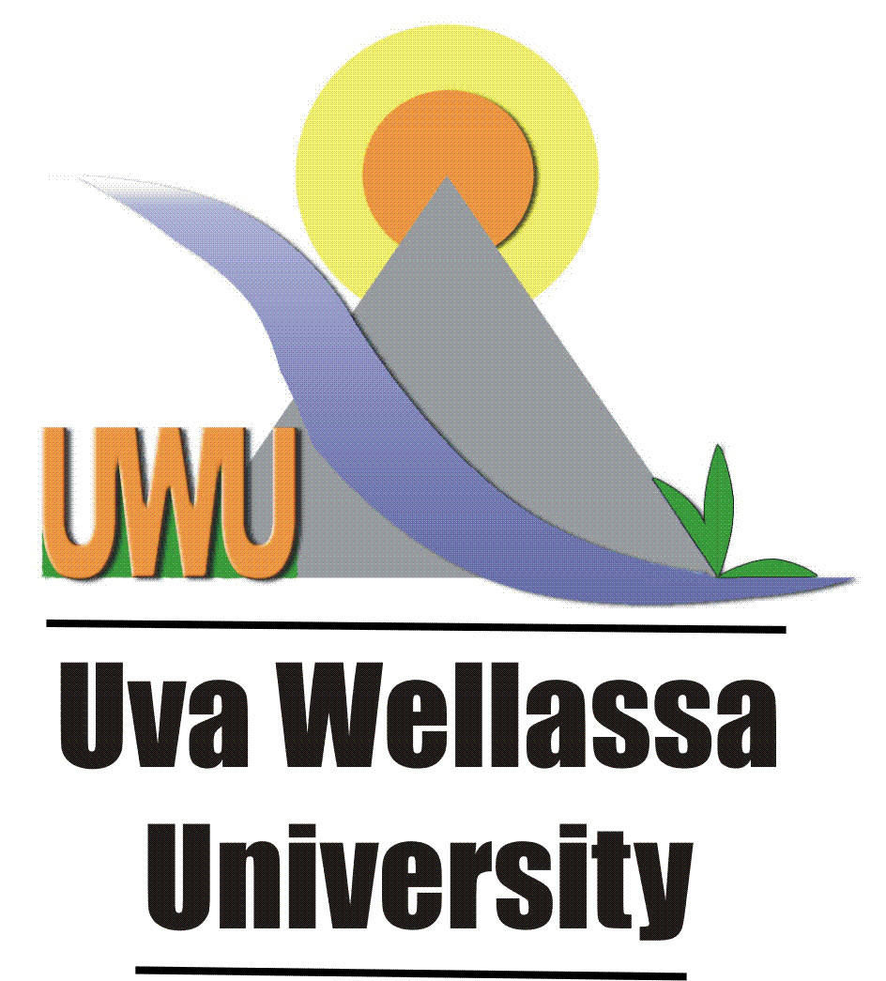  Uva Wellassa  University  Uva Wellassa  University
Requester Information

1. | Name |  |  | : …………………………………………………………………………
2. | Designation |  |  | : …………………………………………………………………………
3. | NIC Number |  |  | : …………………………………………………………………………
4. | Contact number |  |  | : …………………………………………………………………………
5. | Reservation purpose |  |  | : …………………………………………………………………………
 | (state whether Official / private) |  |  | : …………………………………………………………………………
6. | Requested place |  |  | Nugegoda ( ) |  |  |  |  |  | Badulla ( )
 | - Tick the relevant place
Important: 01. Make your reservation request must have forwarded to 1 day Prior to SAR-GA office in order to avoid any inconvenience caused. If rooms available will inform you at earliest.

02. Complimentary rooms are provided for official visits only.

Details of the Occupant
No | Name of the Occupant |  |  |  |  |  | NIC number
1.
2.
3.
4.
5.
6.
7.
Note : Mandatory to fill -- information over reservation

Arrival Date : ……………… |  |  | Arrival Time: …………… |  |  | Number of Rooms required…………
Departure Date: ……………… |  |  | Depature Time: …………...
I confirmed above information is true and correct .
……………………………… |  |  |  |  | ……………………………………….
Signature of Applicant |  |  |  |  | Head of the Department
For office use only

No of Rooms Available :…….
Allocated Room No :…………
…………………………………
Signature of Approving Officer

GUEST RESERVATION - Terms & Conditions

1. Guest House is own to Uva Wellassa University.
2. It is non-alcoholic and non – smoking place.
3. Please record your name and NIC number in the guest register after arrival.
4. Keep your Personal belongings under your custody.
5. You are responsible for items own to the university during your stay at the guest house
6. Meals can be obtained from the guest at the approved rates
7. Report any damages during your stay at the guest house.
8. Contact care taker if any assistance required.
9. Complain and inquires please contact: 055- 2226470 – Senior Assistant Registrar.
10. Please produce this reservation form under your custody for avoid any inconvenience
11. Payments can be made to Care taker (Badulla guest house only) or University –Shroff/cashier)
12. Make sure you obtained a receipt for the payment you made.

Hope you will enjoy staying in our Guest House
Thank you.
Uva Wellassa University

