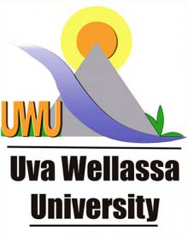
NOTICE
UWU TECHNO CAMP-2020

The Staff Development Centre of the Uva Wellassa University (UWU) will organize a seven-day residential training programme “UWU TECHNO CAMP-2020” for Technical Grade Officers from 29th March to 04th of April 2020.

Target group : Technical Grade Officers
Venue : Main Lecture Theatre (MLT) and Laboratories
of Uva Wellassa University
Course Fee : Rs. 2,500.00/participants
Accommodation : Free of Charge
Course Content :

- Nano Technology
- Quality Assurance and Control
- Contribution of technical officers to research activities
- Fire safety
- Laboratory design
- Financial regulations, Handling and maintaining the inventory
- Procurement procedure & auditing
- Work Ethics
- Laboratory safety and Laboratory waste disposal
- Toxicity Levels and harmful effects of chemicals
- Maintenance of modern laboratory equipment
- Introduction to computers and Industry 4.0
- Computer software/hardware/liveware
- University administration procedures
- Non communicable diseases
- Promotion scheme of technical officers

Applications can be downloaded from the website www.uwu.ac.lk. Duly filled applications should reach “Director, Staff Development Center, Uva Wellassa University, Passara Road, Badulla” through proper channel on or before 11th of March 2020.
Payment has to be made to Bursar, Uva Wellassa University, Acc. No. 3114820, Bank of Ceylon, Badulla. The copy of the payment slip must be attached and sent with the application. Please write a remark “REGISTRATION FEE FOR UWU TECHNO CAMP-2020 (Your Name)” on the payment slip.

Prof. D.K.D.D. Jayasena
Director/Staff Development Center
Uva Wellassa University
24/02/2020

