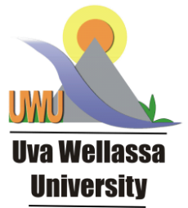
Walk in Interview
Post of Temporary Research Assistant
Academic Research and Publication Unit

Suitable qualified graduates are invited for a walk-in interview for the post of Temporary Research Assistant

Required Qualifications:
- Candidate should possess Degree in any field obtained from a recognized University with the 1st or 2nd class
- Working knowledge and Experience in the research and publication will be an added advantage

Selection Method:
Selection will be done base on the walk-in interview and the date and venue of the interview as follows;
Date - 19.03.2020 at 10.00 am
Venue - Board Room in the Administrative Building, Uva Wellassa University, Badulla

Required Documents for the Interview:
- Curriculum vitae (CV)
- All relevant academic certificates and certificates to prove extracurricular activities (Originals and copies)
- National Identity card (NIC)
- Research publications (if Available)

Period of Contract:
The contract period for the above post is one (01) year and renewable based on the performance.

Remuneration:
The Basic Salary of Rs 49,860.00 will be paid for a month and Cost of Living allowance of Rs. 7,800.00 per month will be paid as an allowance.
You will be required to contribute to University Provident Fund as per the existing regulations.

For more details
Director, Academic Research and Publication Unit - 0702543554
SAR, Academic Research and Publication Unit - 0779224108

