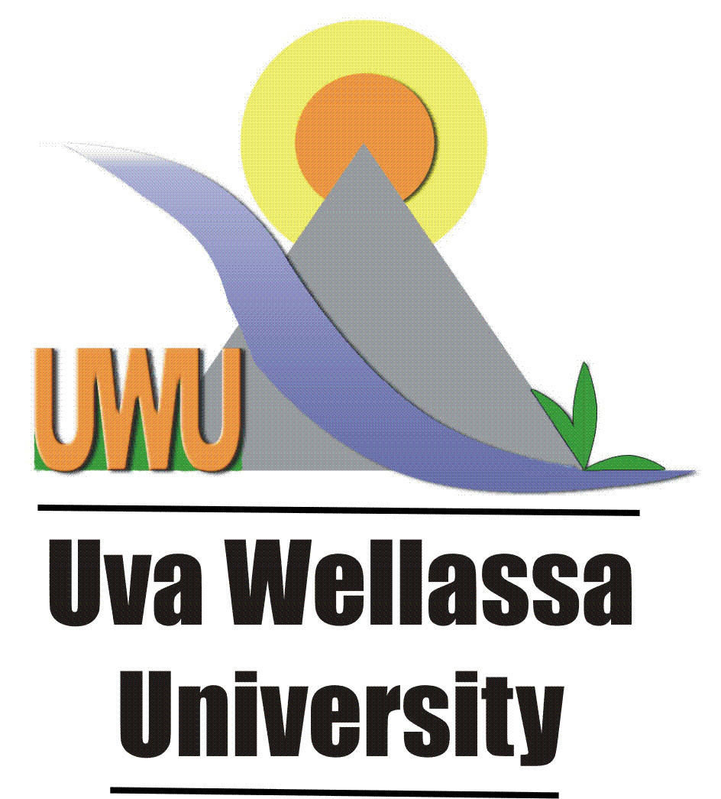

Uva Wellassa University of Sri Lanka

GENERAL CONVOCATION FOR CONFERMENT OF DEGREES
SUPPLICATION FORM

- Name with initials: Mr/Ms ………………………………………………………………………………

- Whether the Name Confirmation Form already submitted to the Examination Division

Submitted Not-Submitted

- Full Name in English (Write In Block Letters): *** Students those who have not confirm their name to the Exam Division by Submitting the Name Confirmation Form, should fill this

- Should confirm to the spellings of your name used in the provisional certificate.
- Changes in the name given above will not be allowed later.

- Permanent Address: ……………………………………………………………………………..
........................................................................................................................................................................................................................................................................................................................................
- NIC No:

- Gender(Pl tick the relevant cage): Male Female

- Name of the Faculty: ……………………………………………………………………..

- Registration No: .………………………….…………………………………………..

- Title of the Degree: ………………………………………………………………………..

- Effective Date of the Degree: ………………………………………………………………………

- Contact Telephone Number(s): Mobile; ………………………………………..
Land Line; …..……………………………………

- E-mail Address:

- Whether the Degree is to be Awarded (Pl tick the relevant cage)

In-Person In- Absentia

• If these cages remain unmarked, it will be presumed that you will not attend the Convocation.

- No-Claim form (Pl tick the relevant cage)

Submitted Not-Submitted

- Copy of the paying-in-voucher of the payment for Rs.1000/- is attached
(Pl tick the relevant cage)

Yes No

(Payment can be made to the University Shroff Counter or as the Convocation fee to any branch of Bank Of Ceylon to be credited to the University A/C number 3114820 (Badulla Branch)

14.If you wish to be conferred the Degree in person, please indicate the names and the National Identity card numbers of the two persons who will attend the proceedings in the Convocation Hall:

1 ………………………………………………………….. N.I.C. No:………………………………………
2 ………………………………………………………….. N.I.C. No: ……………………………………..

I certify that the information provided above is true and correct to the best of my knowledge.

Date:……………………….. Signature of the Applicant:………………...

Closing Date for Receiving the Completed Supplication Form: 17th July 2017 (On or before 3.00 pm)

Please Write “General Convocation 2016”on the top left hand corner of the envelope containing the application form.

Return the duly completed Supplication Form addressed to the Assistant Registrar, Examination Division, Uva Wellassa University, Passara Road, Badulla. on or before 17th July 2017

